DIFFRENCES BETWEEN TECHNOLOGIES and PROJECT UI
1-> In Start New Technology the Title and Category are aligned in one Line where as in Projects The Title and Category is not aligned in one Line and the Title Text box is too big as compared to Technology Title TextBox

For Technology Title 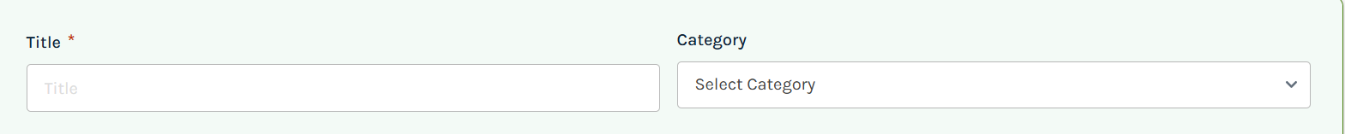
For Project Title 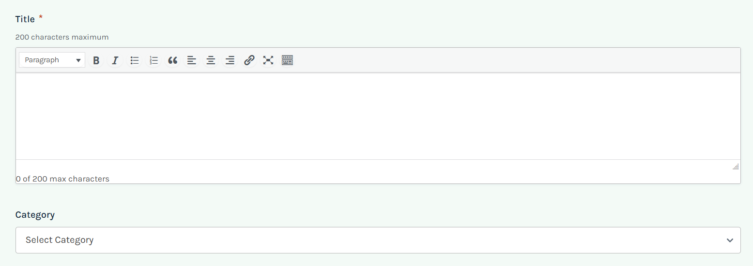

2->In Start New Technology Page the short description and long description Text boxes are aligned properly where as in the Start New Project page the short description and Long description boxes are not aligned accordingly
For Technology Page 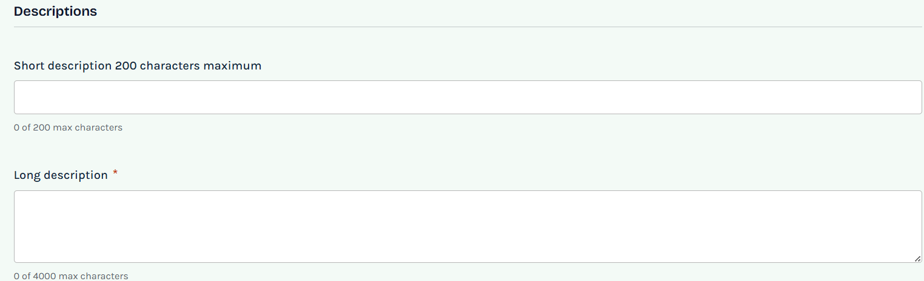
For Project Page 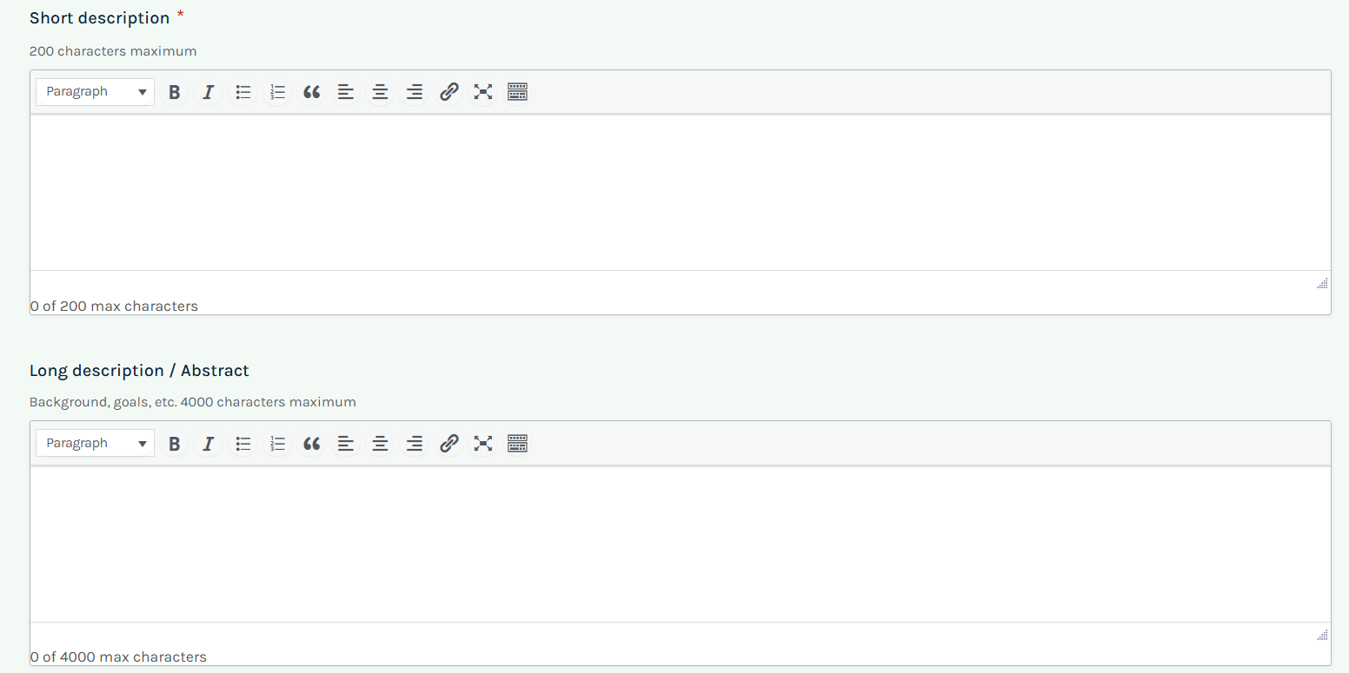

3->In the Start New Technology page the potential application Text box is aligned properly where as in Start New Project page the text box seems a bit Large even the maximum number of words section is within the same Text box in Project Page.

For Technology Page 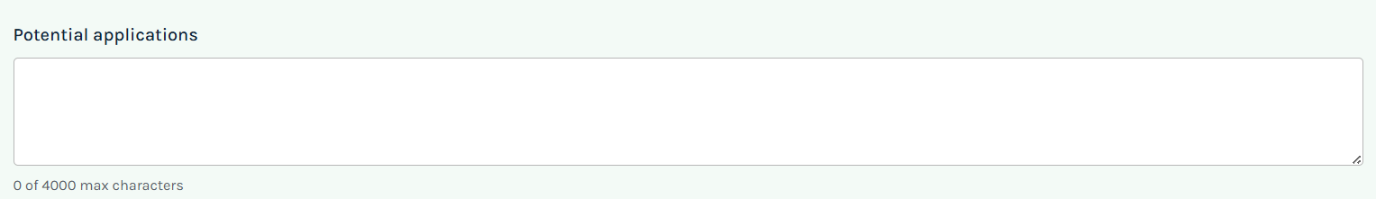

For Project Page 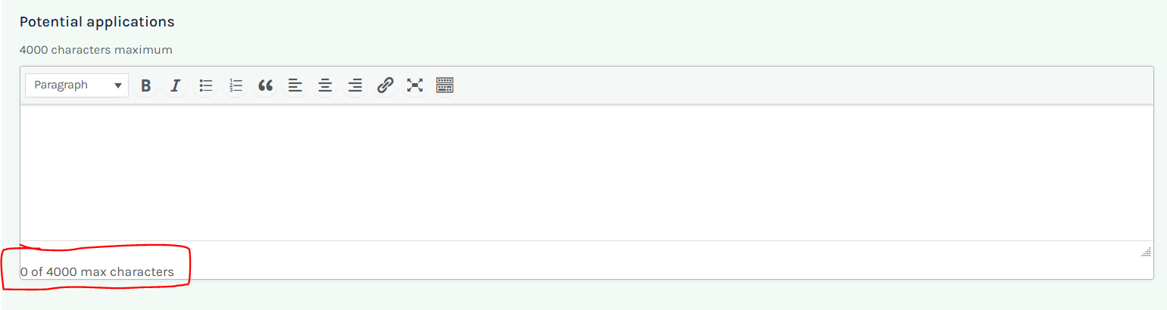

4->In the Start New Technology The Tags Text Box is in a specified Length but in the Start New Project Project page The Text Box length is Bit lengthy.
For Technology Page 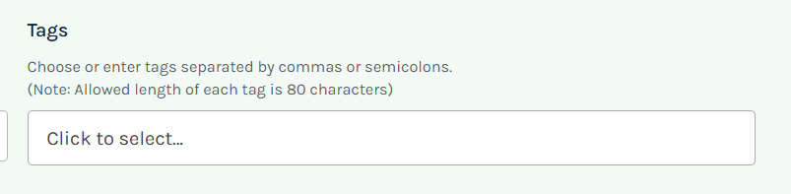

For Project Page 