DEMO REPORT: -
(Public/Private Technology, Knowledge Uploads/Preprint, Create Technology/Start project UI, Add Team Members)

1. Knowledge Uploads/Preprint
a-> In the author section if we select multiple authors then its overlapping the text box.Proper alignment required (NOT FIXED, TOS-135)


b->In the Dropdown section proper alignment is required (NOT FIXED, TOS-135)
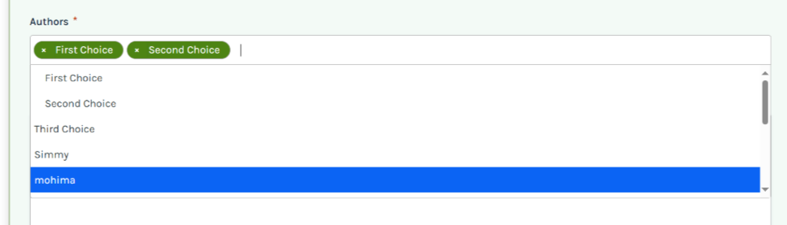
c->While trying to Nominate other preprints/manuscripts for DOI throwing attached error as well as the Failed to load form hasn’t been aligned properly (NOT FIXED, TOS-135)

d->Image is uploaded but not displaying beside the uploaded preprint(To-do, TOS-134,Need to discuss)
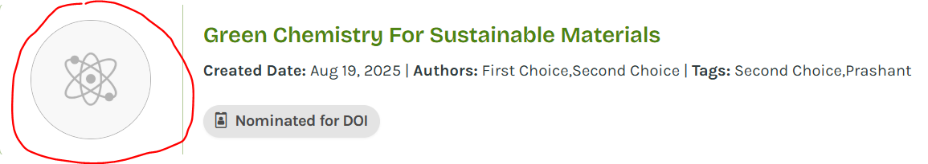

e->Currently, the ‘Brief’ section is clickable (the pointer icon appears on hover) and is causing the page to refresh. (To-do, TOS-134,Need to discuss)

f->Add a star to indicate mandatory fields. . (To-do, TOS-135)

g->When the user nominates the preprint for a DOI from the summary page, the success pop-up UI is not proper. (To-do, TOS-135)

2-> Create Technology/Start project UI
The below are not Fixed (TOS-136)
ADD SCREEN: Create Project: Validation message verbiage needs to be consistent

Create Technology:

7. EDIT SCREEN: Edit Screen Project: Extra heading is visible

Edit Screen Technology:

8. Edit Screen Project: General validation message populating
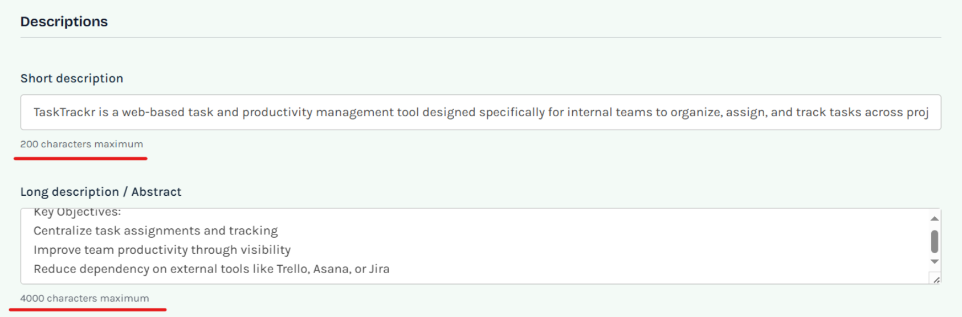
Edit Screen Technology:
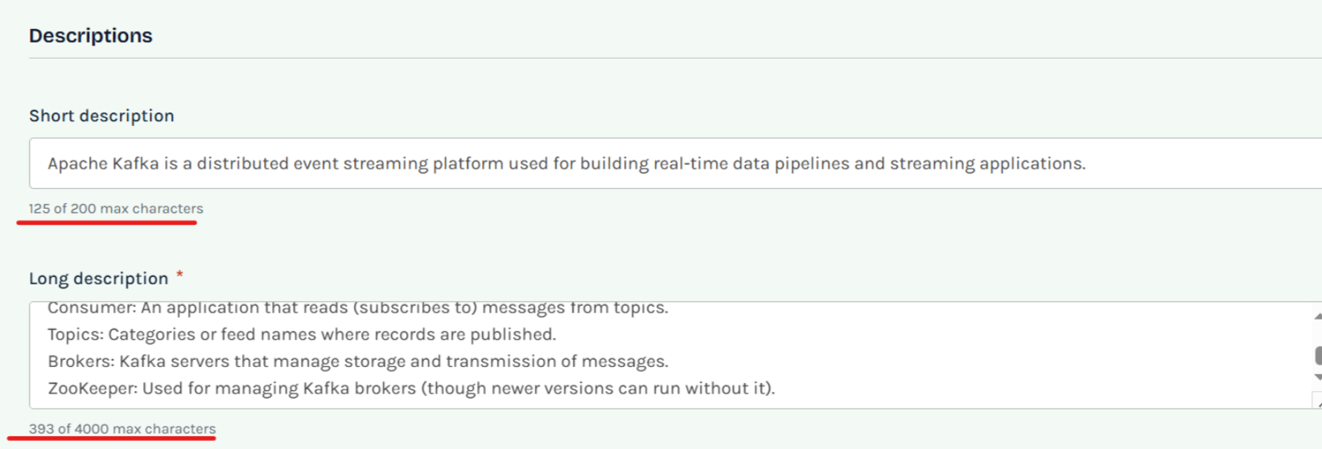

4->In the Create project under the Tags section once the specific Tags are getting selected they are moving towards the right need proper alignment(NOT FIXED)
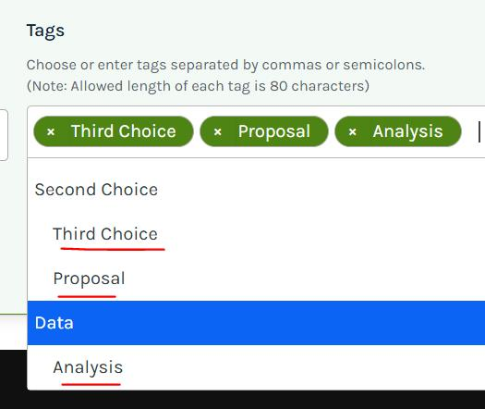

3- >Public/Private Technology and Add Members

1->Technology_private
a->Clicking the invitation notification should redirect to the 'Teams' tab in the Technology module. Currently, it navigates to the Technology Summary page. (NOT FIXED, TOS-123)

b->After the invitation is approved, the private technology should be listed on the Technology listing page, forums, and global search result as the user is now associated with it. (Partially Fixed ,now the technology is listed on the Technology Listing page and the Forums page, but it is not appearing in the Global Search results, TOS-123)

2->Project_Private

a->The technology creator should not be able to add themselves; they should only be able to add other registered users.(NOT FIXED, TOS-133)

b->Clicking the invitation notification should redirect to the 'Teams' tab in the Project module. Currently, it navigates to the Project Summary page.(NOT FIXED, TOS-133)

c->After the invitation is approved, the private project should be listed on the Project listing page, forums, and global search result as the user is now associated with it. Currently, it not appearing Technology Listing page. other pages it's appearing. (Partially Fixed (now the project is listed on the Forums page, but it is not appearing Global Search results and Technology Listing page(when serach that private project in the listing page then it will display))

