Below are the Project page observations
1->In the new site for Project the Title of the webpage is not in one line

2->In the new site under Brief section the Recent Activity box is not present but in the old site the box is present.
OLD SITE:- 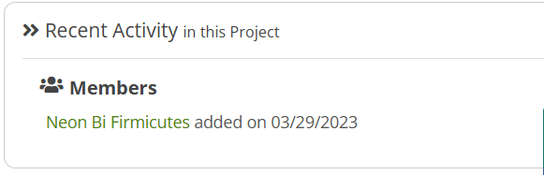

NEW SITE:- 

3->In the Patented workspace some of the pointers are missing in the new site under the Brief section.

OLD SITE:- 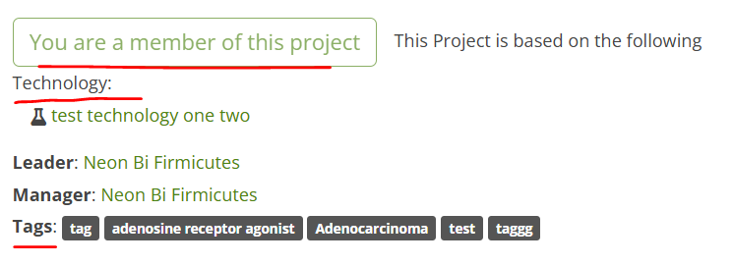
NEW SITE:- 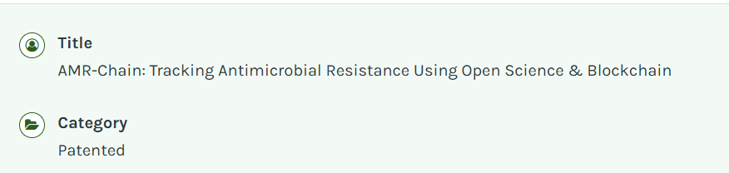

The EDIT Button is also missing under the Brief section.
OLD SITE:- 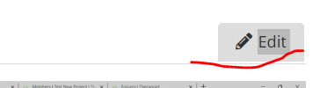

NEW SITE:- 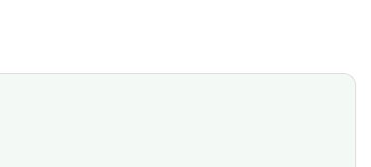

4->In the new site under patented project for Long Description and Potential Applications paragrahs are starting with HTML Code. 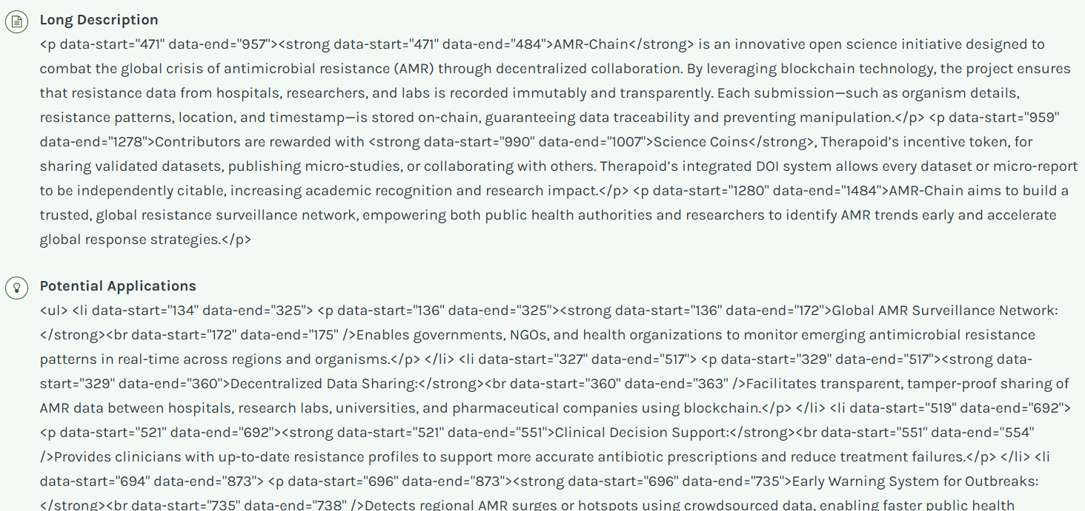

Below are the observations for Edit profile page:-
1-> I am selecting the time zone for Asia/Kolkata but after saving the profile page by default its selecting the time zone for America/NewYork

Before saving->
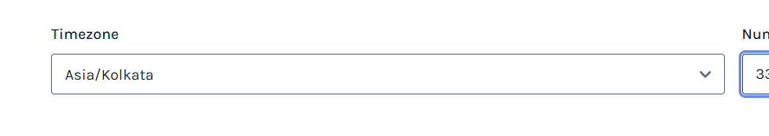

After saving->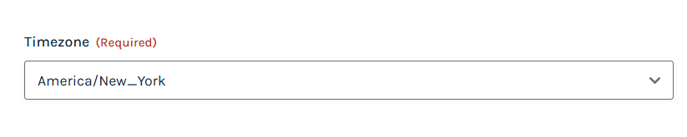

2->While selecting the country in the dropdown menu once the country name is selected but after saving the country name it is not sticking to the box.
Before saving:- 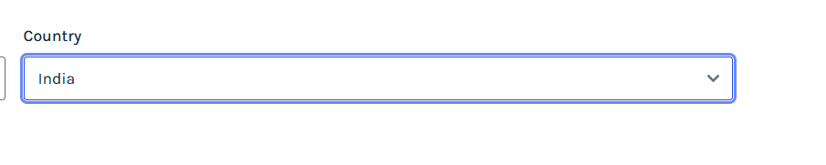

After saving->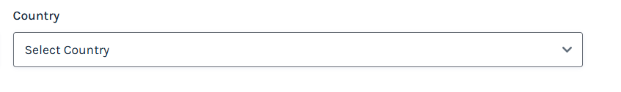

3->In the Peer review section once we enter the peer review and then save the numeric review is not sticking to the box after clciking on save.

Before saving->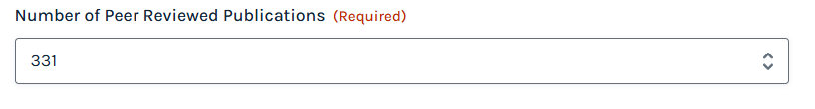

After saving->