Home - https://teraopenscience.v2soft.com/
- The ScienceCoins image is missing from the header section.
- The font size of the ‘Collaboration Platform’ label is much smaller compared to the old site, and the exclamation mark (‘!’) is missing.
Old Site: -
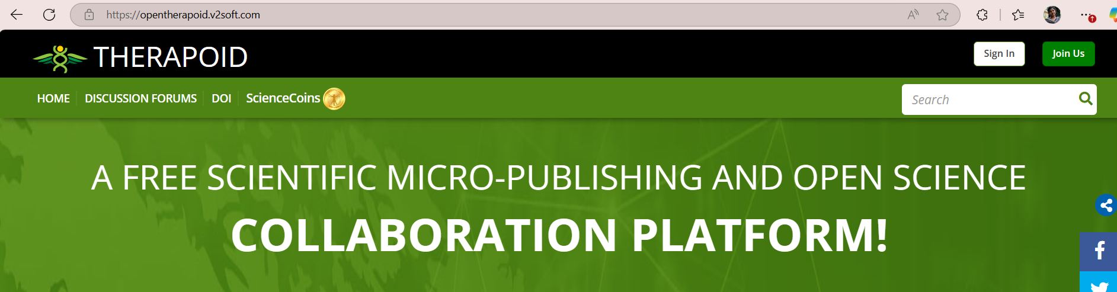
New Site: -
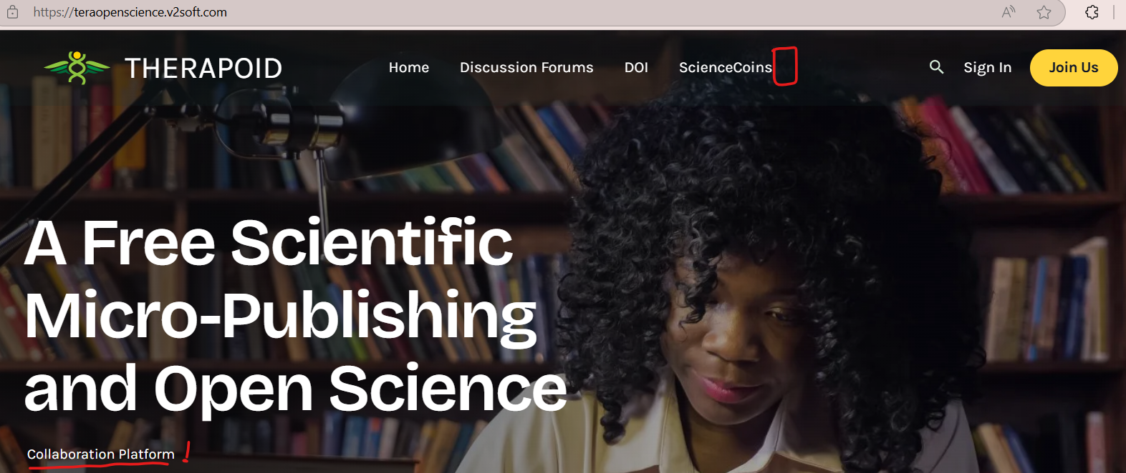
- ‘ScienceCoins’ menu label is not displaying properly after clicking the search icon.
- ‘Sign In’ does not appear like a button.
Old Site: - New Site: -

- In the new site, the ‘SIGN-IN’ button and ‘DISCUSSION OF THE WEEK’ are not included within the content section.
Old Site: -
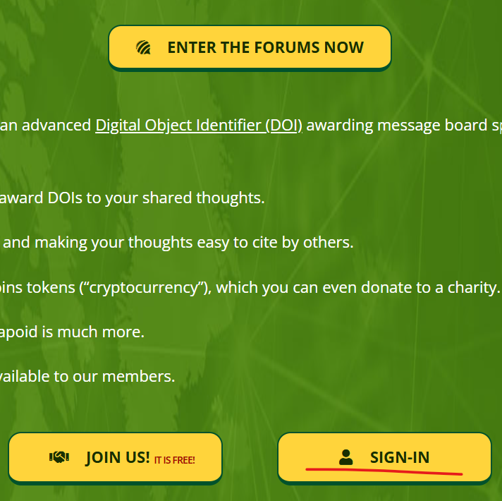
Old Site: -
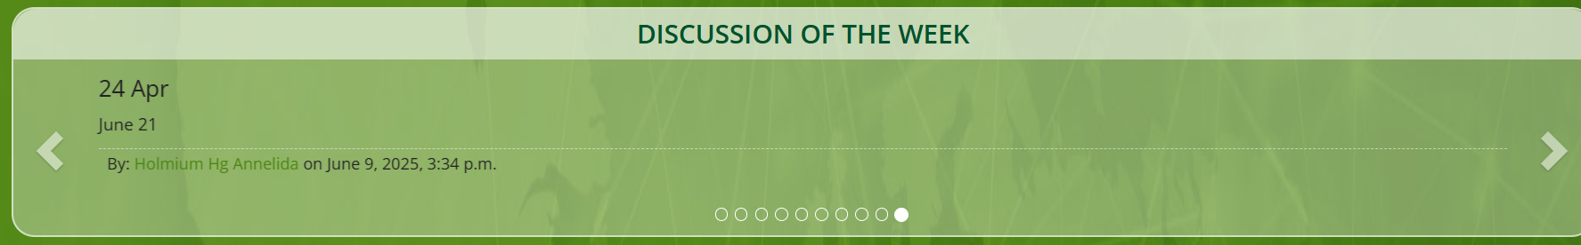
- There should be appropriate spacing between each paragraph for better readability.
Old site: -
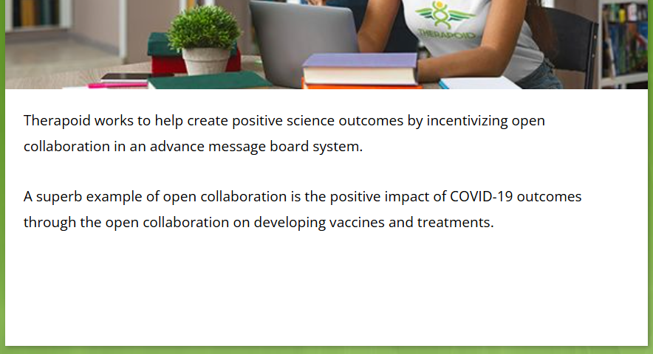
New Site: -
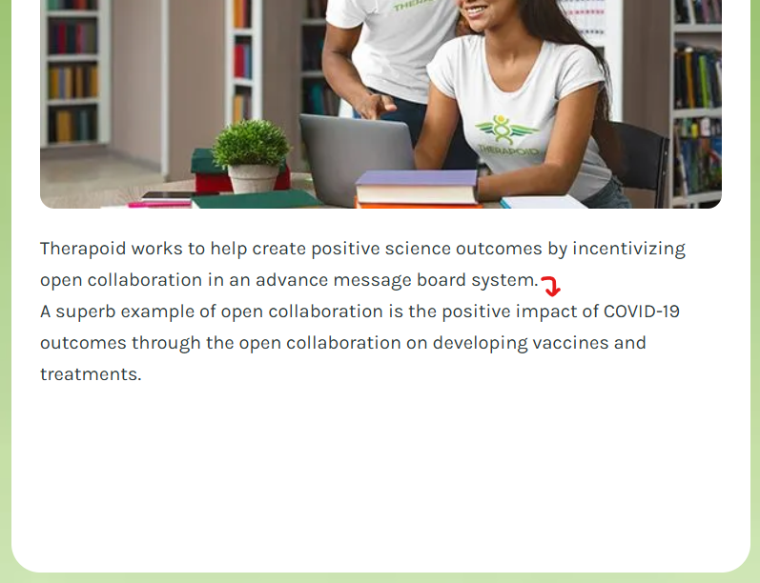
- In the 'Collaboration + Awards' section of the old site, there is a 'So freely join Therapoid' link. However, in the new site, the text appears, but it is not functioning as a clickable link.
Old site: -
New site: -
- On the new site, in the ‘After joining, you gain free access to:’ section, the ScienceCoin image is missing, and the ‘JOIN US NOW’ button does not include its icon.
Old site: -
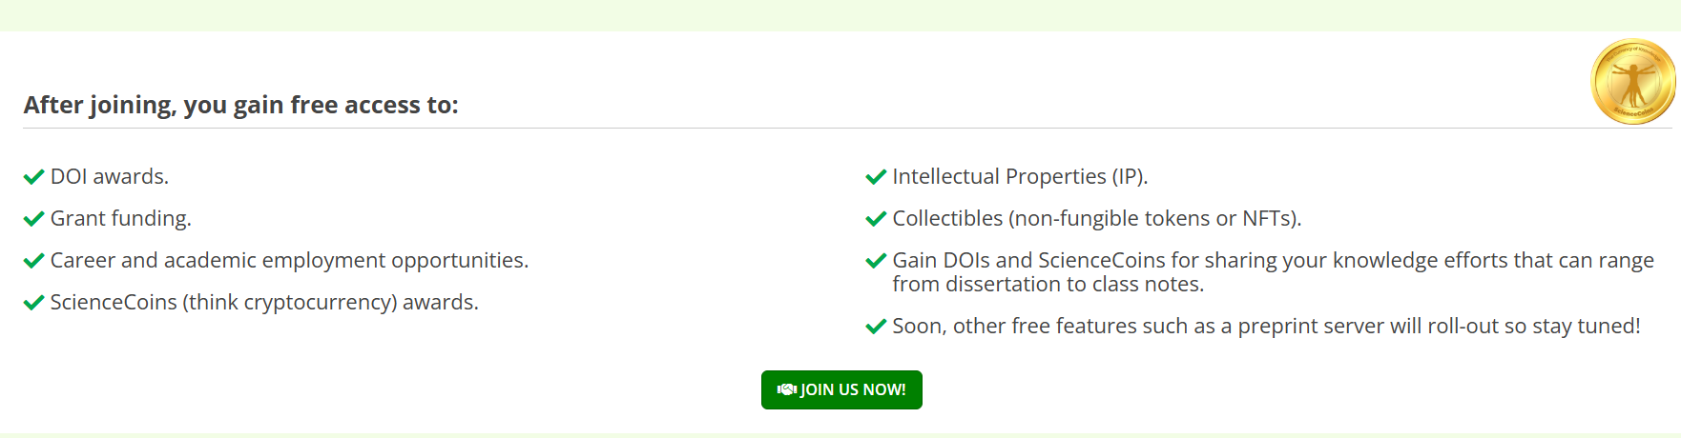
New site: -

- In the 'How does it work?' section of the old site, the content includes two links. On the new site, the text is present, but the links are not clickable.
Old Site: -
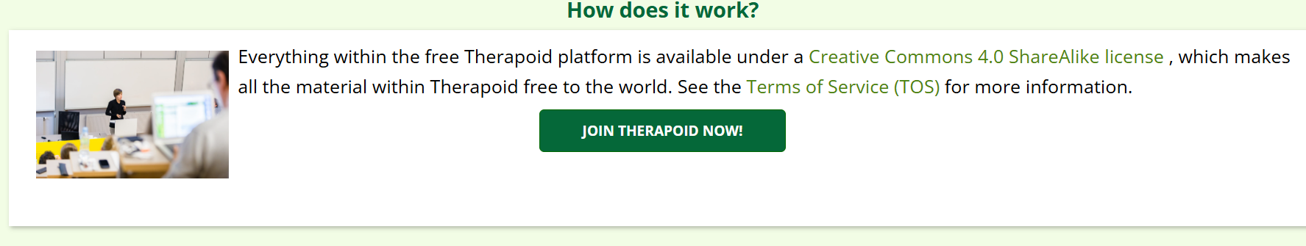
New site: -
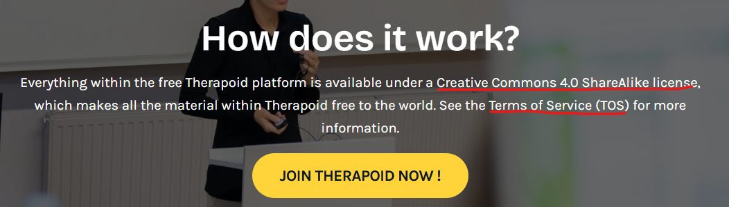
- The tooltip is missing on the new site.
Old site: -
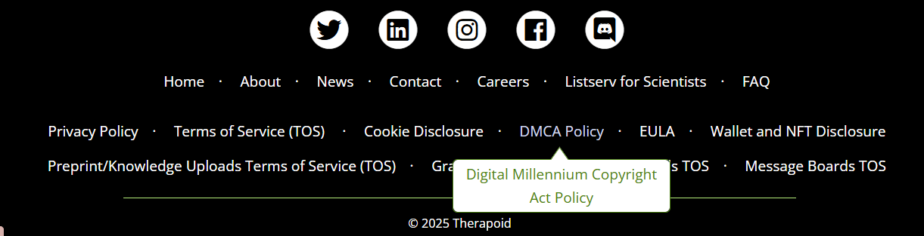
New site: -
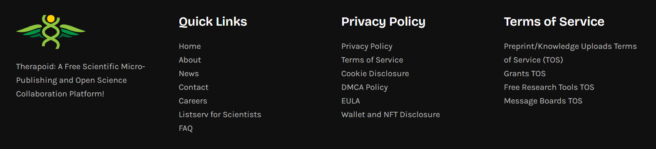
- The sticky header is not clearly visible after scrolling the page.


