Grants Functionality Related Observations
1. Grants: Change the verbiage Funding to Grants --> FIXED

2. Create Grant: Able to create a grant without filling in any of the fields. --> FIXED
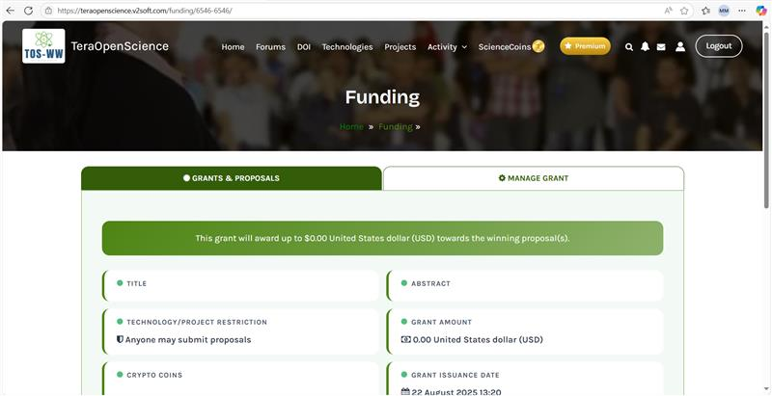

3. Create Grant: System is accepting voting dates that are later than the proposal end date — this should be restricted. --> FIXED

4. In the old site under the file section File name, description and Delete file tabs are present but in the new site no such tabs are there --> Not an issue (this is the new functionality form the gravity form so we used this functionality)
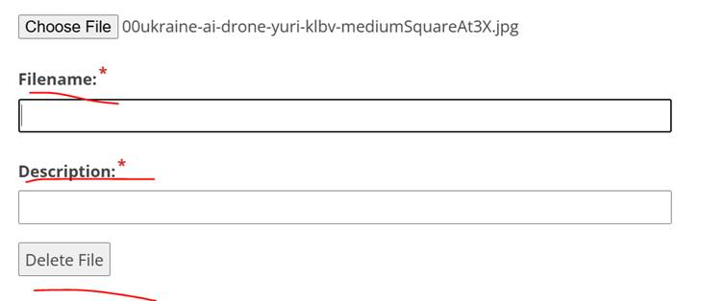

5. Grant Listing page: Creator: The creator of the grant has the option 'Open for Applications'. Clicking on it displays an error pop-up as shown below. --> FIXED
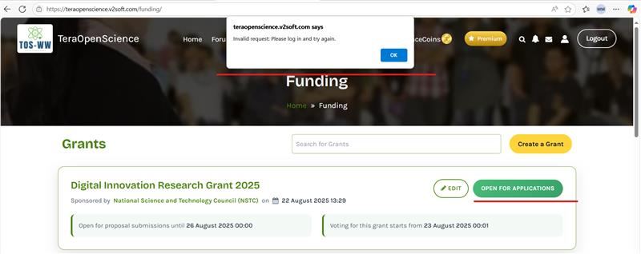
6. Grant Listing page: Proposals: Creator of the Grant: Remove the option to submit proposals for their own grants -> Need to verify

7. Grant Listing page: Creator: The creator of the grant has the option 'Edit'. Clicking on it will redirect to 'Manage grants', but details are not pre-populating --> FIXED
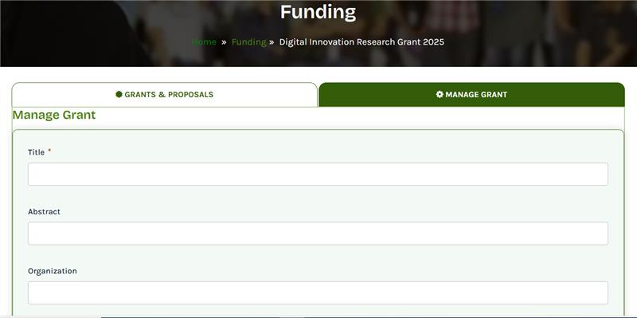
8. Submit Proposals Admin: The submitted proposal is not being displayed in the Admin dashboard. --> FIXED
9. Submit New Proposals: Change the verbiage Funding to Grants in the breadcrumb --> Not released
10. Submit New Proposals: Remove the ID from the breadcrumb --> Not released
11. Grant Summary: Please make rupee to Rupees --> Not an issue (Old site value is Rupee only so we added as "Rupee")
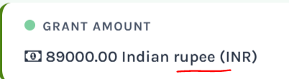
12. Grant Summary: The Tags section is missing after the Project --> FIXED
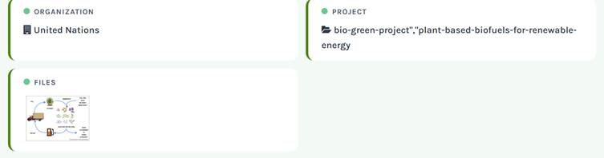
13. Grant Summary: Remove the apostrophes and hyphens from the added project --> FIXED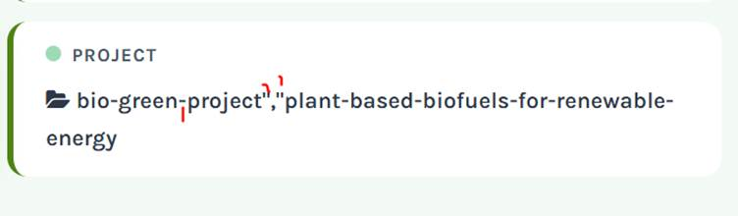
14. Grant Summary: After creating a Grant, the currency awarded is in INR, but the display is showing $ and makes rupee to Rupees --> Not released
15. Grant Summary: After creating the Grants the order should be Title, Abstract, Technology/Project, Projects/Technology, Tags, Amount, Currency, Crypto Coins, Crypto currency, Proposal start, Proposal End, Voting Start, Voting End but the order is mixed up --> Not Fixed -> Retest

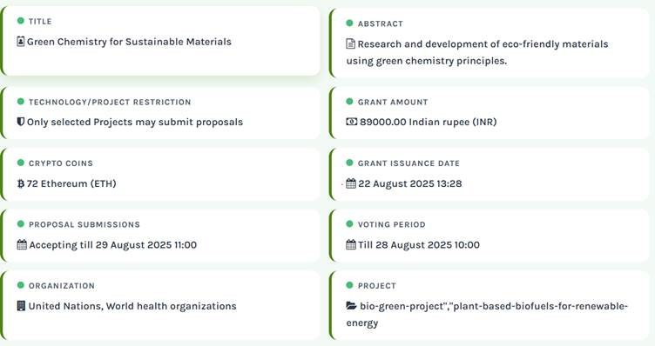
16. Create Grants: Change the verbiage Funding to Grants -> FIXED
17. Create Grants: Change the verbiage Create Funding to Create New Grant -> FIXED
18. Submit Proposal page: Change the verbiage Funding to Grants
19. Submit Proposal page: Add breadcrumb as Create New Grant Proposal
20. Submit Proposal Admin page: Does not display which grant the proposals are associated with. --> FIXED
21. Grants Listing page: As the Organization field is not mandatory when creating a grant, it left empty, which results in incomplete information being displayed later. --> FIXED
22. After submitting the proposal, display a success message or some confirmation to indicate that the proposal has been received.
23. Change the wording because the user is viewing proposals submitted by others, not their own.
24. Please confirm what it means
25. Expecting ‘Manage’ option for creator before the admin approval
26. Submit proposal option is missing for the Grants if ‘Technology/Project restriction’ added as ‘Only selected Technologies may submit proposals’ or ‘Only selected Projects may submit proposals’
27. Proposals: Creator: Remove the below verbiage
28. Submitted Proposals: Date is incorrect
29. Grant created: Creator tries to edit (tags and projects fields): Then getting error in the date fields
30.

