Knowledge Uploads/Preprint
1-> In the author section if we select multiple authors then its overlapping the text box.Proper alignment required
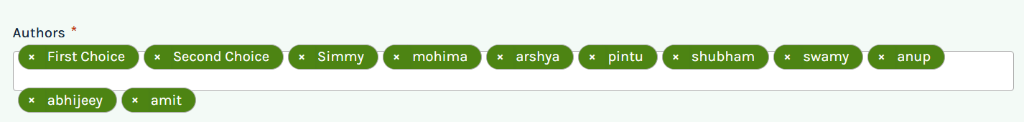

2->In the Dropdown section proper alignment is required
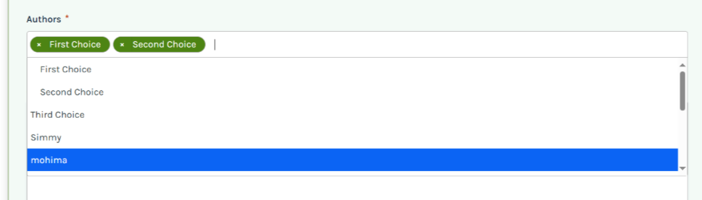

3->The uploaded image description should come below the Text box
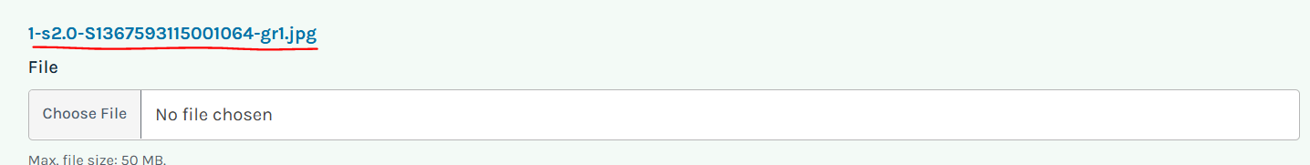

4->Image is uploaded but not displaying beside the uploaded preprint
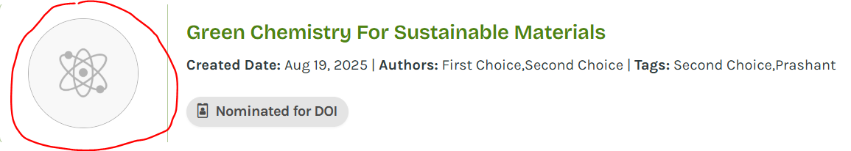

5->While trying to Nominate other preprints/manuscripts for DOI throwing attached error as well as the Failed to load form hasn’t been aligned properly


6->The Title field is missing before Authors
