Table of contents
Contents
Wallet Creation Process (First-Time Users) 2
1.1 ADD YOUR WALLET ADDRESS 2
1.2 Create or add an existing wallet address 2
1.2.1 YES 3
1.2.2 Connect Wallet 3
1.2.3 Enter Your Wallet Address: 4
1.2.4 N0 - > 4
1.2.5 Skip for Now 5
1.3 How to Configure MetaMask Wallet 6
1.4 Token Address 6
1.5 View transaction 6
2. Wallet Address for Existing Users 8
2.1 Establish new Wallet address 8
2.1.1 Steps 9
2.2 Token Contract Address 12
2.3 Transactions 13

Wallet Creation Process (First-Time Users)

1.1 ADD YOUR WALLET ADDRESS

When a user clicks on “Add Your Wallet Address” or selects “Wallet – Inactive” from their profile, they will be redirected to the following page.
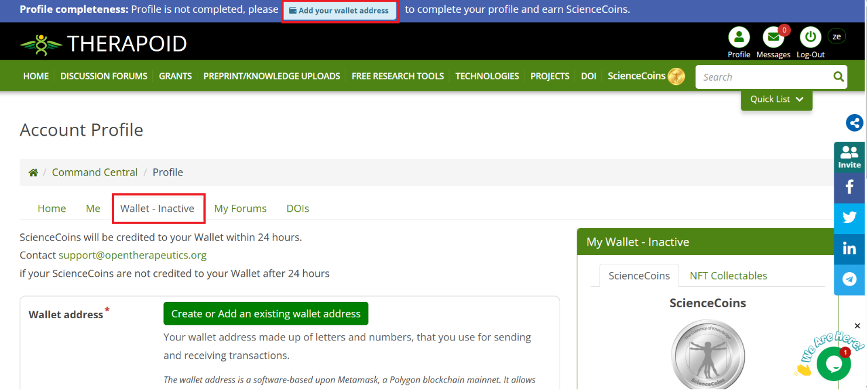

1.2 Create or add an existing wallet address

Even for new users, the system will provide an option to enter a wallet address if they already have one.
When the user clicks on “Create or Add an Existing Wallet Address,” the system will ask:
- Do you already have a wallet?
  - Yes → Proceed to connect or enter wallet address
  - No → Guide user to create a new wallet
  - Skip → Allow the user to continue without linking a wallet (wallet remains inactive)
  - Wallet Disclaimer-> Option to download the disclaimer document.

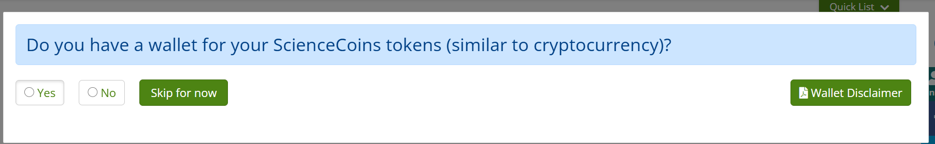

1.2.1 YES
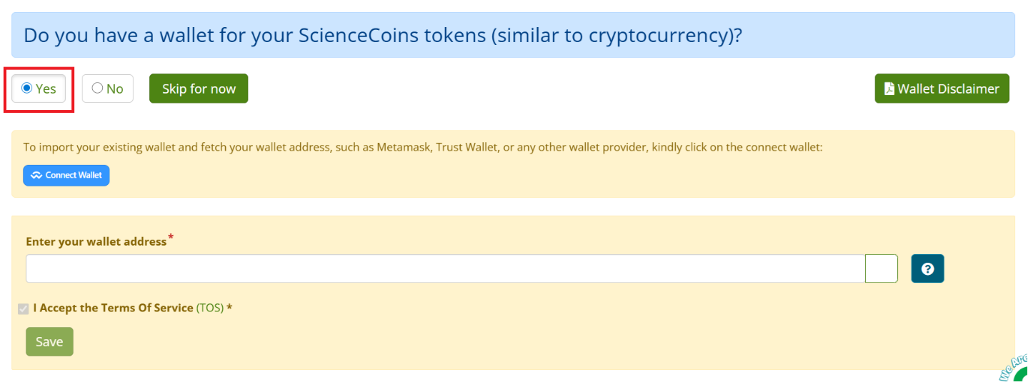

1.2.2 Connect Wallet
- Allows users to connect their mobile wallet using a QR code.
- User scans the QR code with a supported wallet app (e.g., Trust Wallet, MetaMask mobile).
- On successful connection, the linked wallet address will automatically pre-populate in the “Enter Wallet Address” input field.

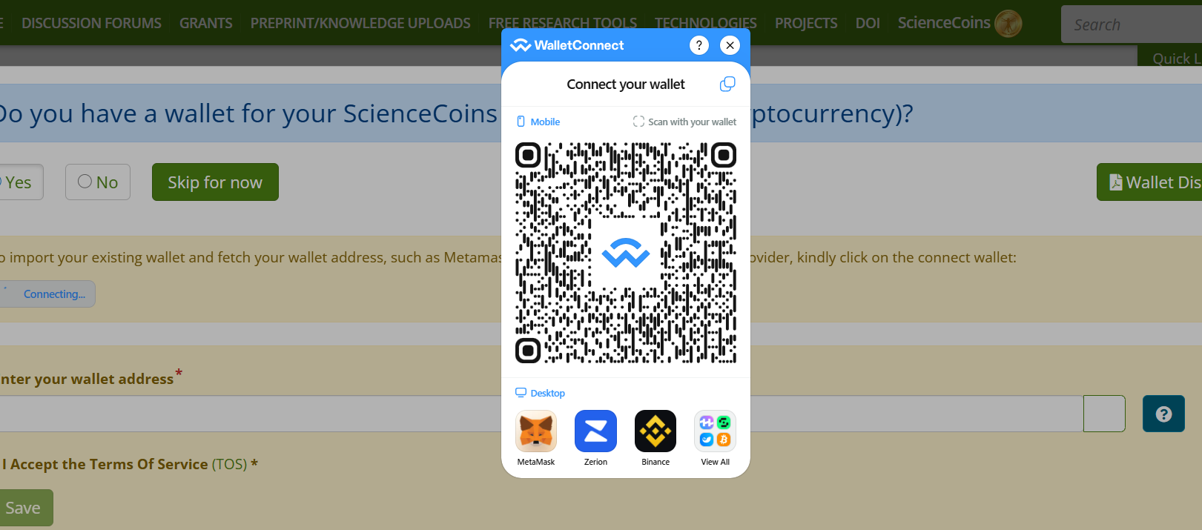

1.2.3 Enter Your Wallet Address:
If the user already has a valid wallet address, they can paste it manually.
- The system should validate the format of the address before saving.
- Once saved, the wallet address must automatically reflect across all required pages (e.g., profile, transactions, rewards, etc.).
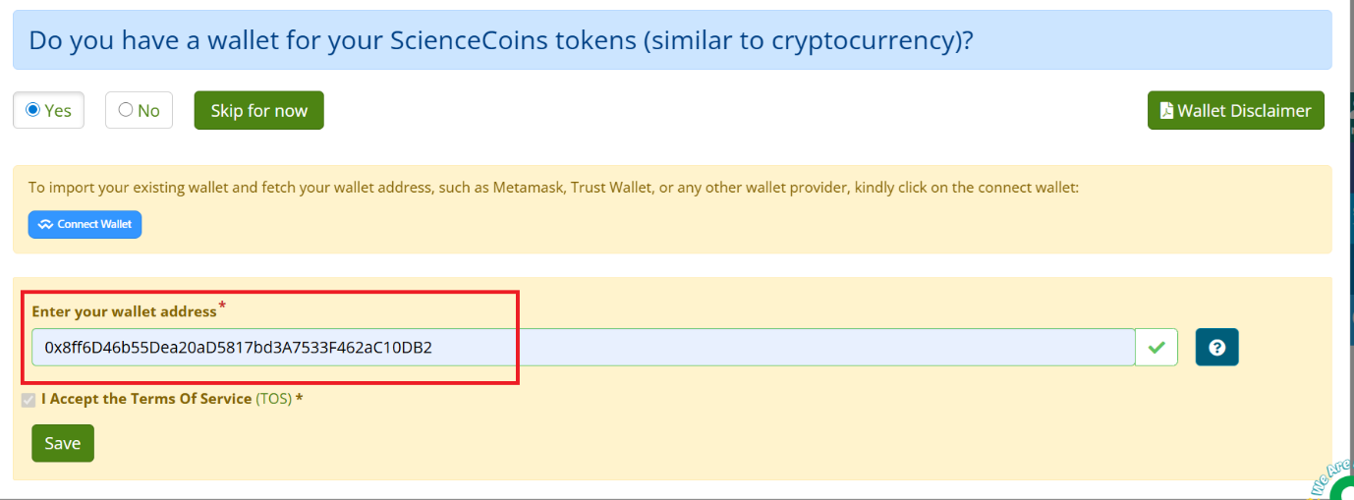

1.2.4 N0 - >
If the user selects “No,” the system will automatically generate a new wallet address.

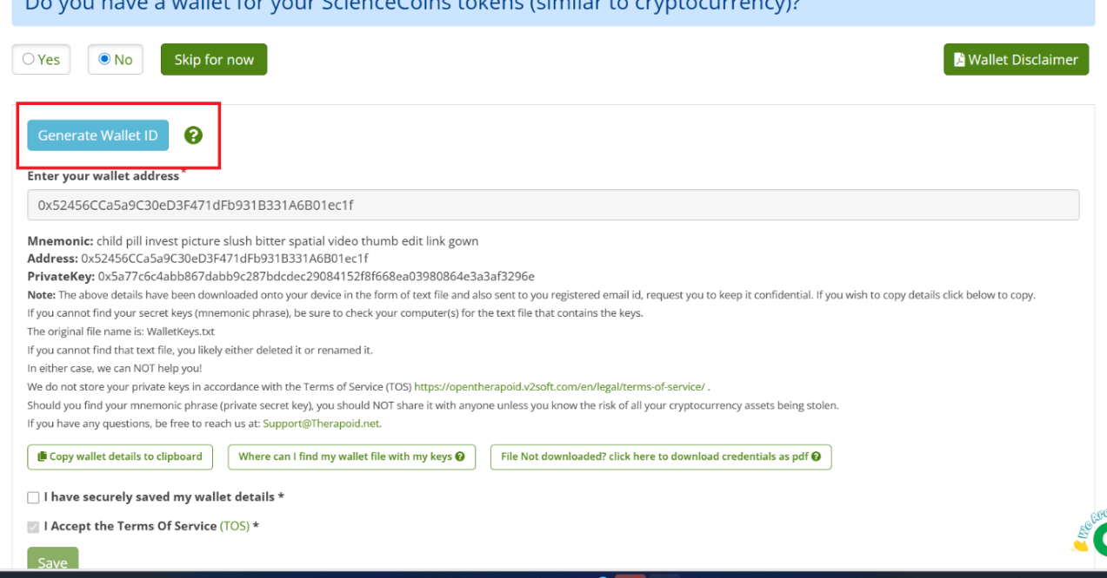
- Automatically generate a new wallet address using secure backend logic.
- The user can generate multiple wallet addresses if needed.
- Each newly generated wallet address will:
  - Be displayed immediately in the wallet address input field.
  - Be added to a list of recently generated wallet addresses.
  - Be reflected across all wallet-related fields
- Mnemonic: This is a memory
- Address: Recently Generated Wallet Address
- Private Key: Need to discuss

Confirmation Popup
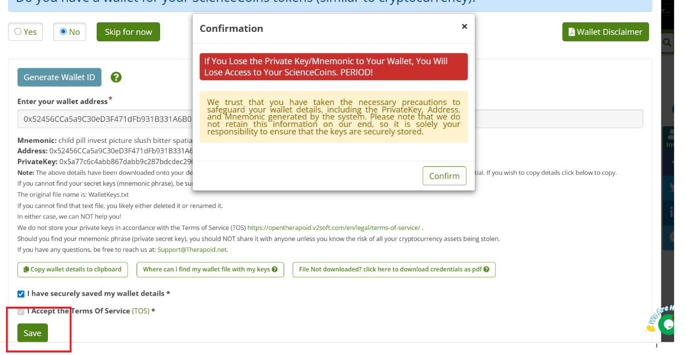

1.2.5 Skip for Now
User can skip wallet setup, Redirected to profile page.
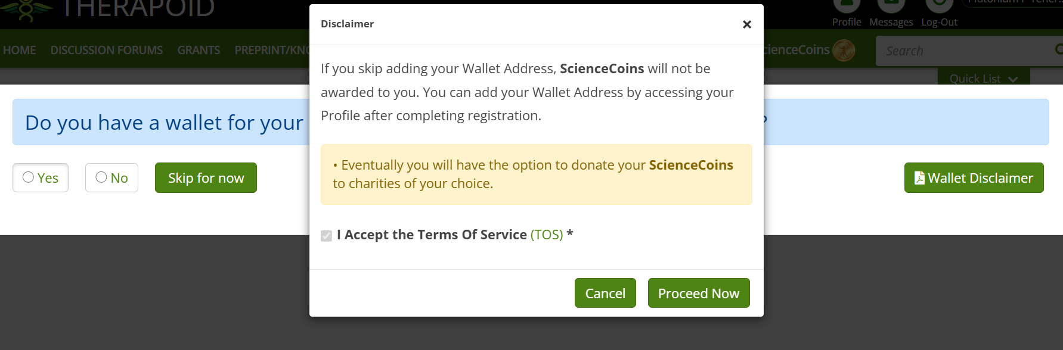

1.3 How to Configure MetaMask Wallet
step-by-step guide to configure MetaMask Wallet
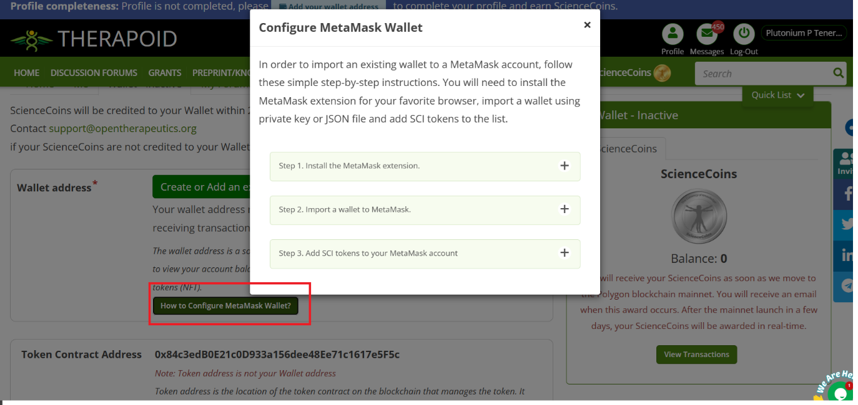

1.4 Token Address
For new user display both Token contract address and Token NFT Address details
NOTE : Token contract address and Token NFT Address will be common for all users
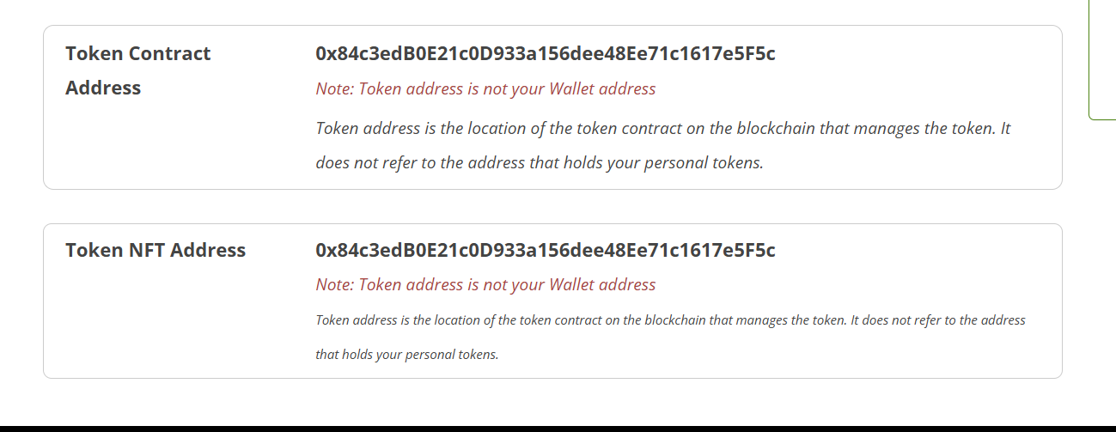

1.5 View transaction
Users can connect or generate wallets to manage Science Coin transactions, view balances, and track activity history.
New users see their Science Coin balance in silver to indicate new user
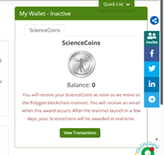
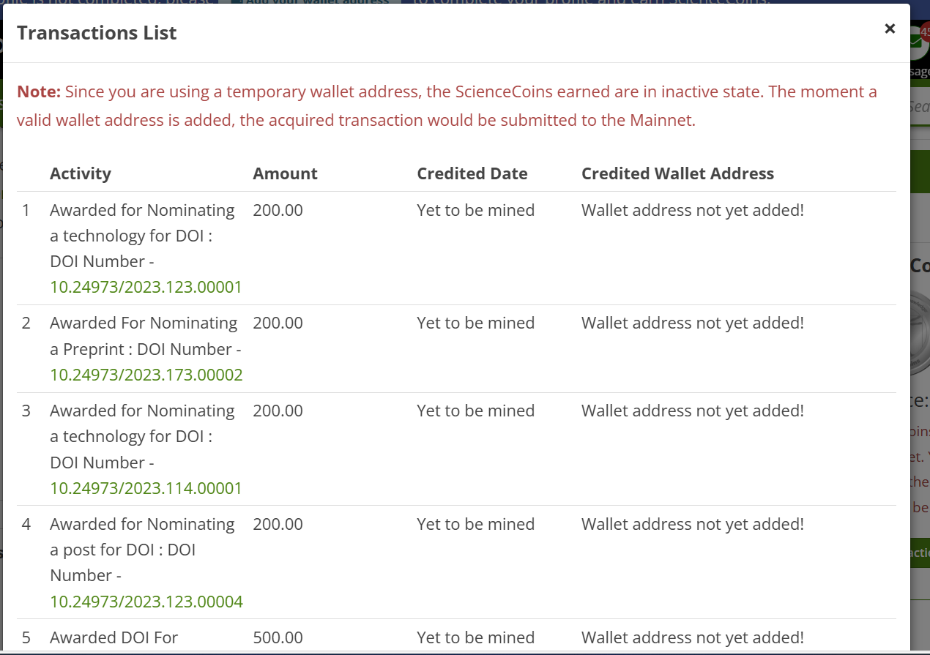
Including Below Transactions
- Nominating a Technology for DOI
- Nominating a Preprint for DOI
- Nominating a Post for DOI –
- Awarded DOI for Technology
- Awarded DOI for Preprint / Knowledge Upload )
- Awarded DOI for Post –
- Registration –
- Profile Completion (via ORCID / LinkedIn upload, etc.)
- 10 Post Creation Milestone –

2. Wallet Address for Existing Users

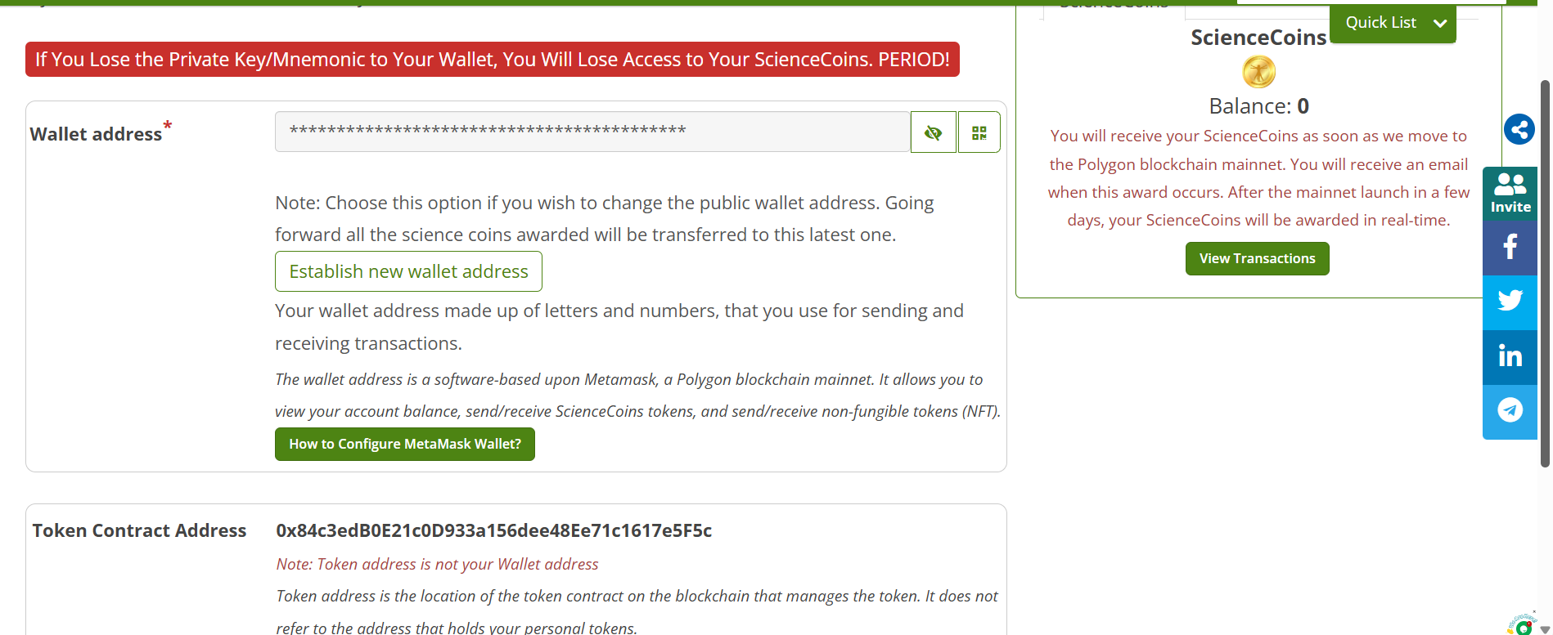

  - Establish new Wallet address If the user wants to create a new wallet address:
- The system will auto-generate a unique wallet address.
- Display the newly created wallet address to the user.

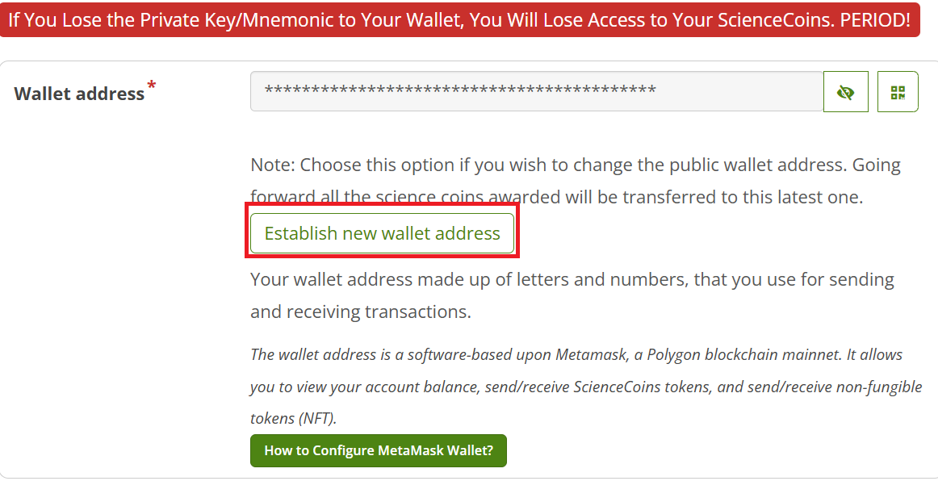

2.1.1 Steps
Step1 : Confirmation Popup
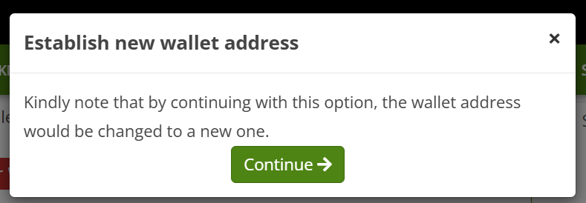

Step 2 : If user click on Generate wallet address , system will generate wallet address automatically
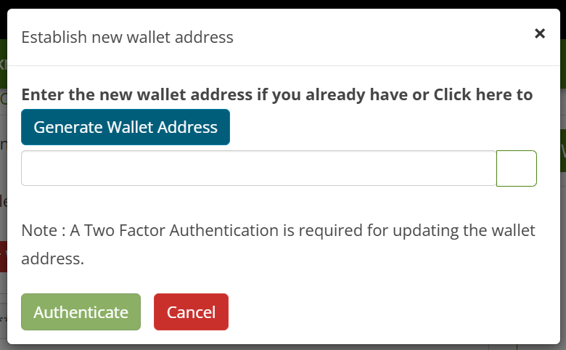

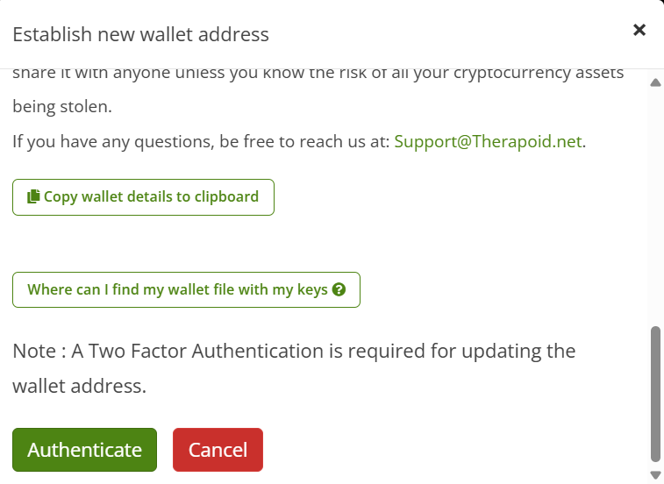
Where can I find my wallet with my keys
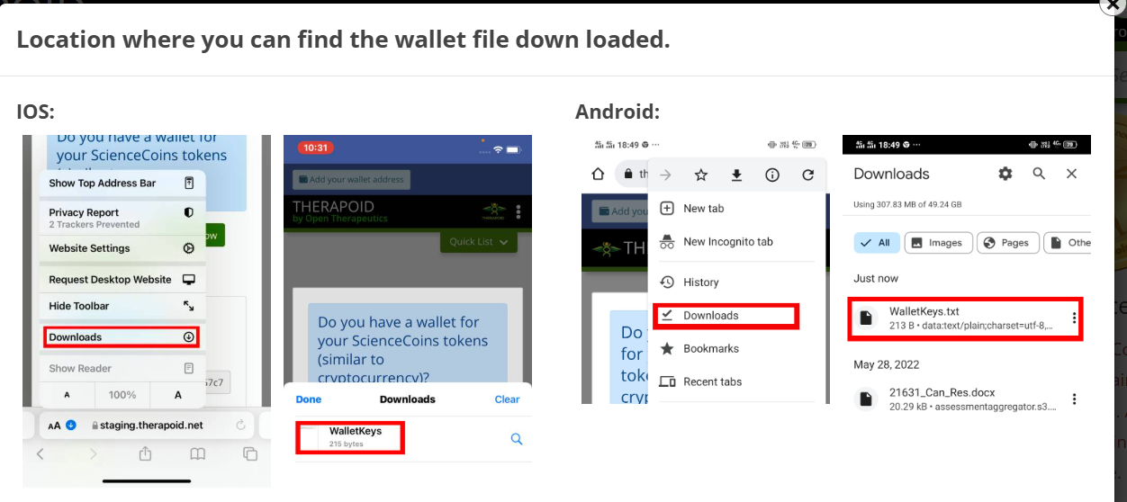

Step 3: Authenticate
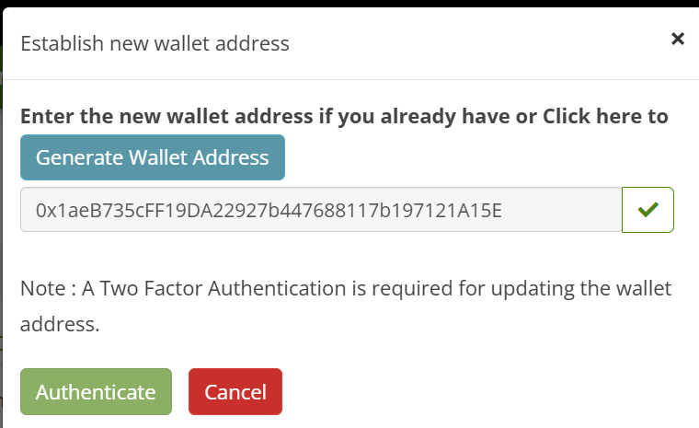

2.2 Token Contract Address
Token Contract Address will be same for all

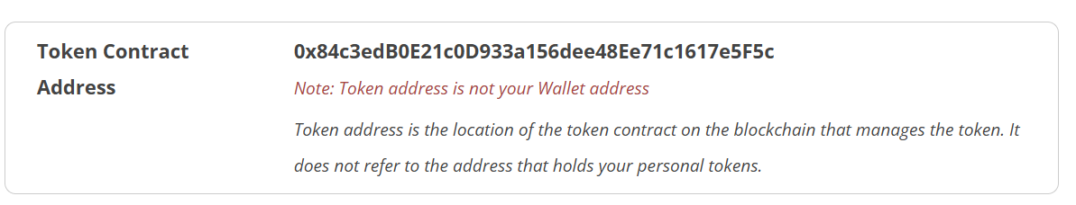

2.3 Transactions
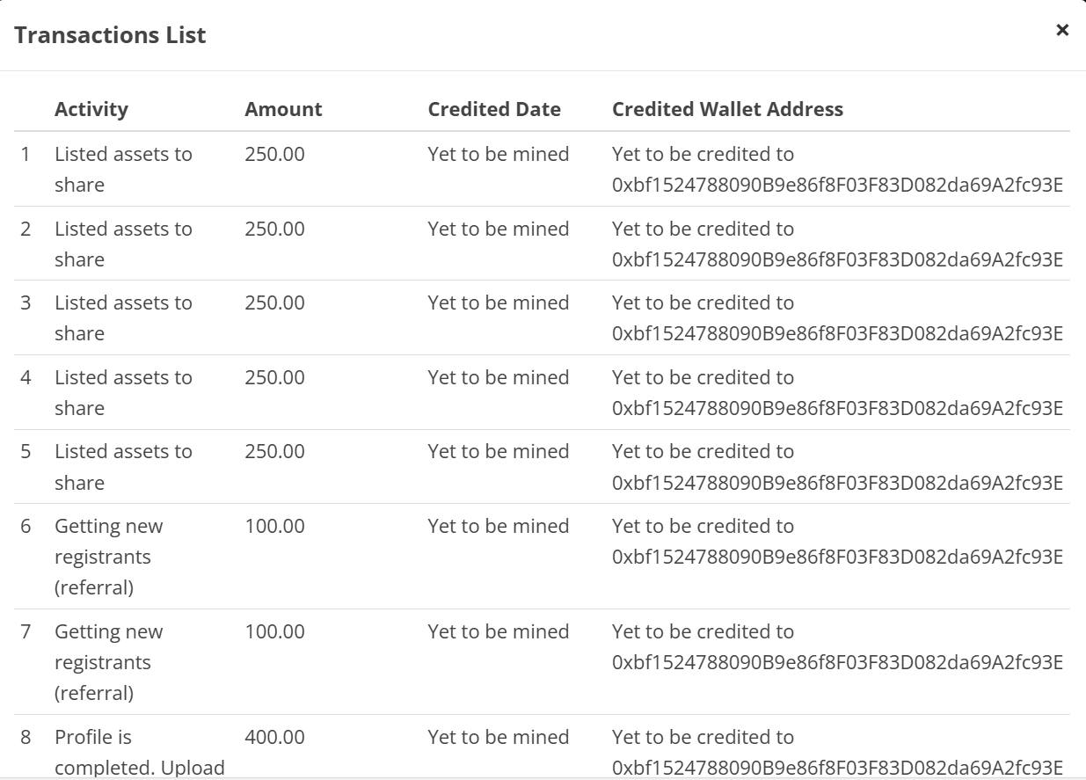
Activity | Describes the reason or type of transaction.
Amount | This value is fetched from the Token field in the Admin SCI Detailed Activity Log.
Created Date | This value is taken from the Mined Date field in the Admin SCI Detailed Activity Log.
Created Wallet Address | The user’s wallet address will be displayed here

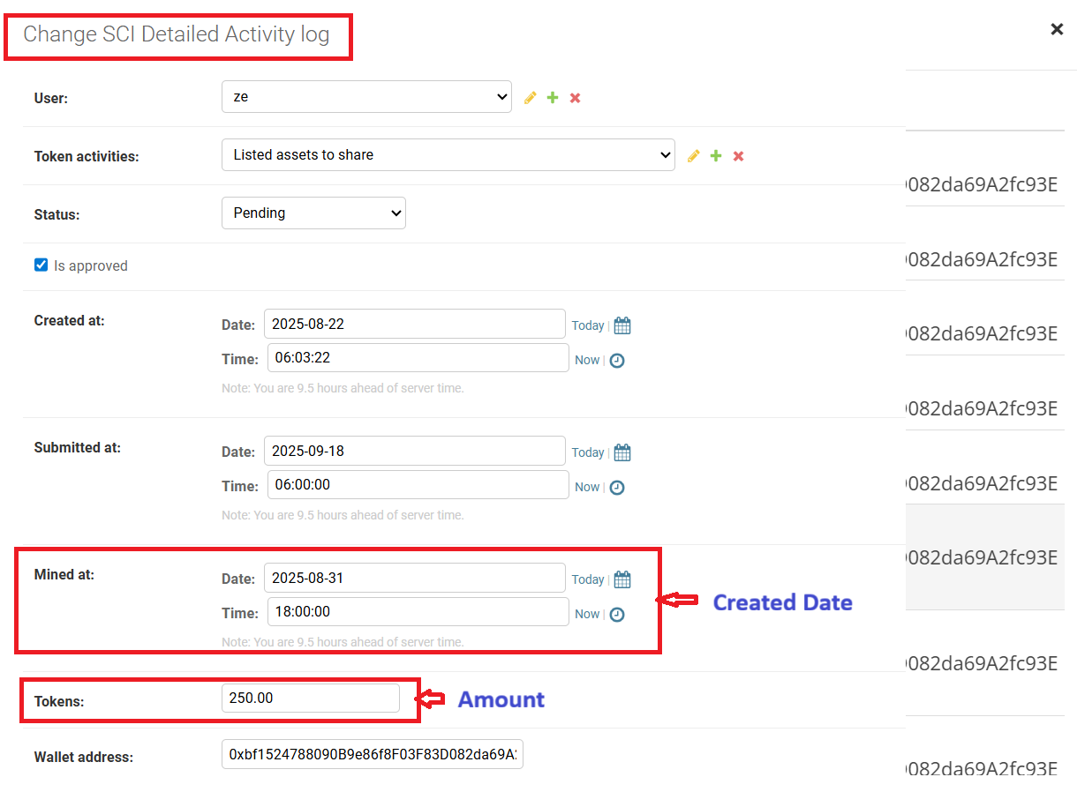

NFT Collections
- Each NFT has a unique Token ID.
- When a user searches for a specific Token ID, In Admin -> the system should fetch and display the details of that NFT
