Discussion Forums: https://teraopenscience.v2soft.com/forums/
- The background image is mismatched.
- The sentence 'Message boards for students and researchers' should be displayed within the banner.
Old Site: -
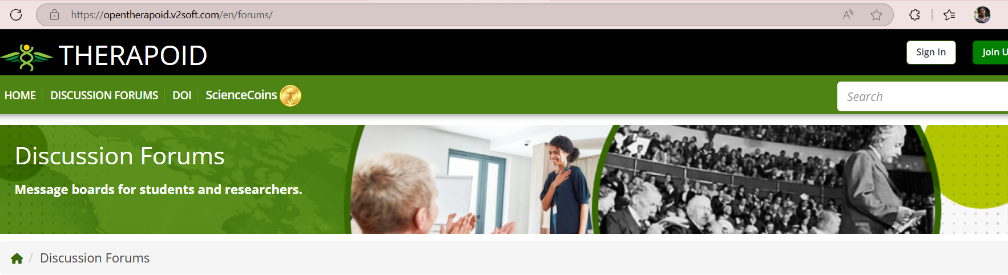
New Site: -


