FAQ-https://teraopenscience.v2soft.com/faq/
1.For question number 9 WHAT IS A CRYPTOCURRENCY WALLET?
Old Site–
In old UI more context was present for LOSE IT. LOSE YOUR SCIENCECOINS. Do not share. 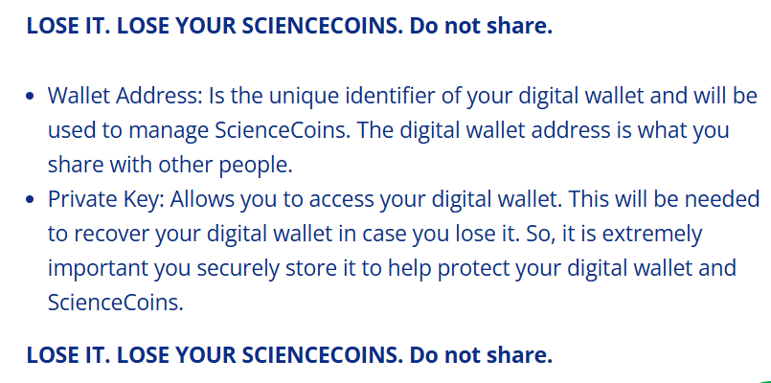
New Site:- In the new site the context seems to missing. 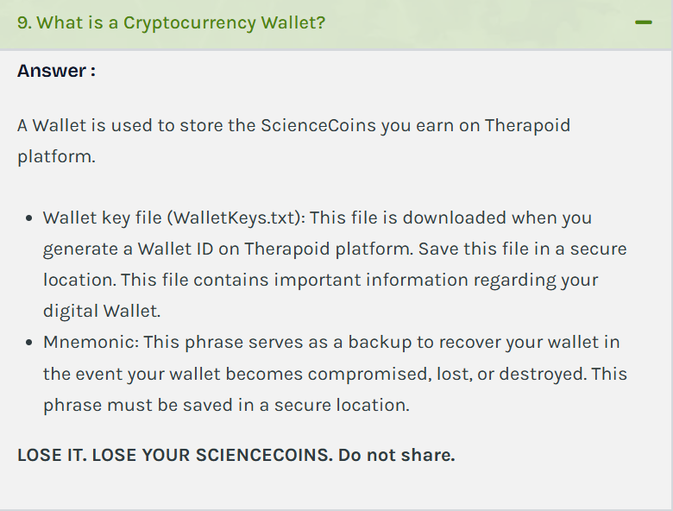
2.For Question number 11 How can I invite my friends?:-
Old Site:-
In the Old site in question number 11 it seems that INVITE YOUR FRIENDS Is a button. 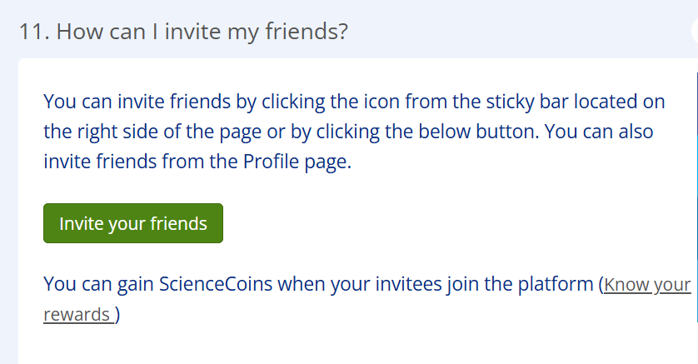

New Site:-
Whereas in new site Invite your friends seems like a link. 